Community Rewards

Open the King Soopers or City Market App.

Click on the dropdown menu in the top right corner.

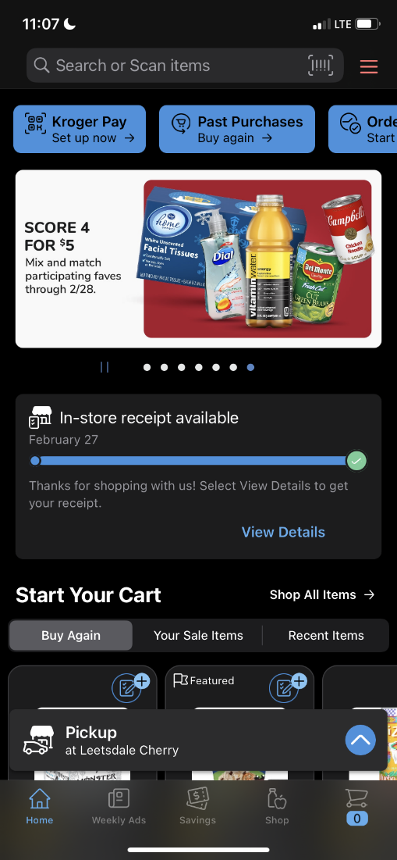

Click on Rewards

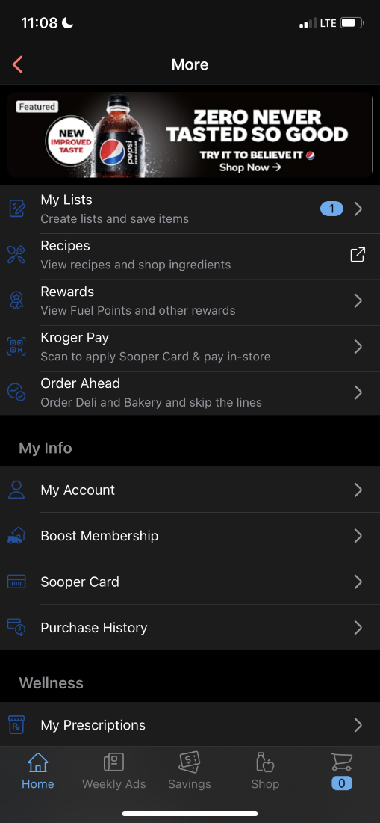

Click on Community Rewards

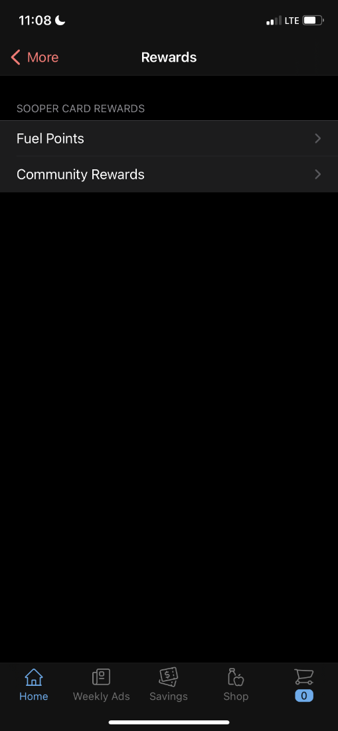

Click on Search for Organization

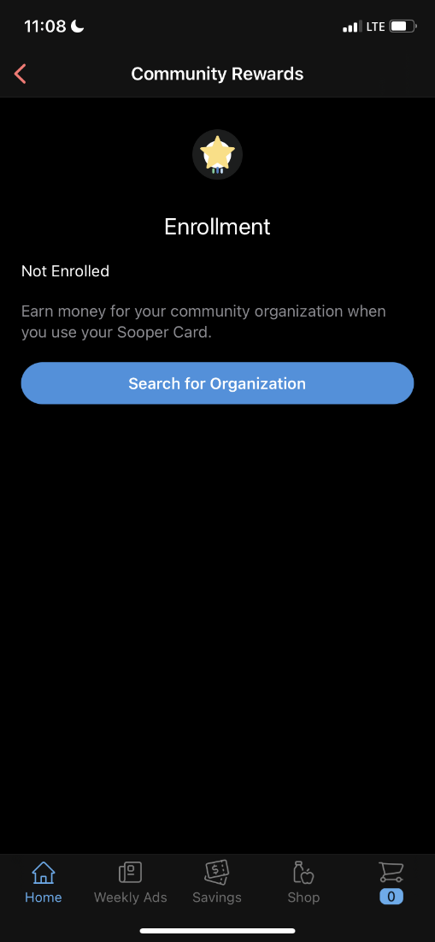

Search by organization name or by relevance

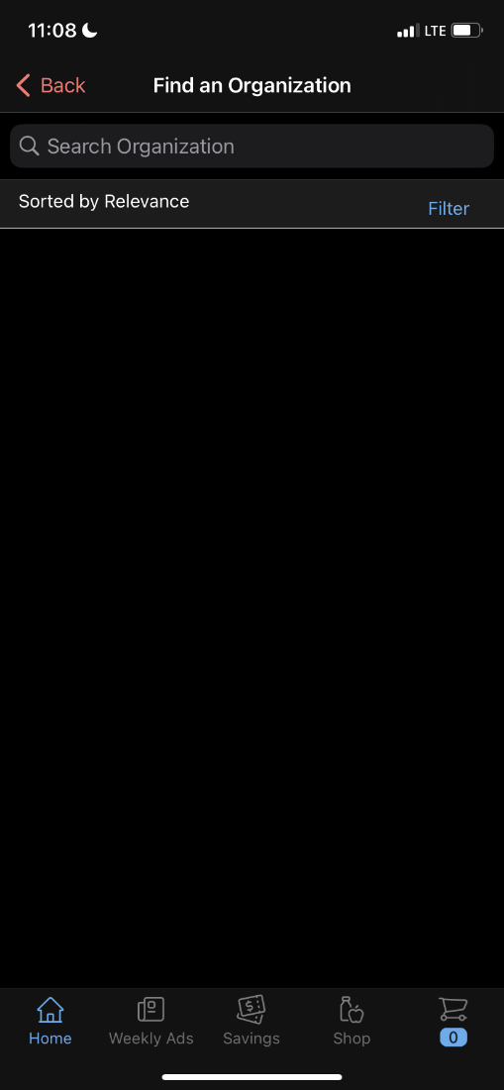

Select from the dropdown if searching by relevance

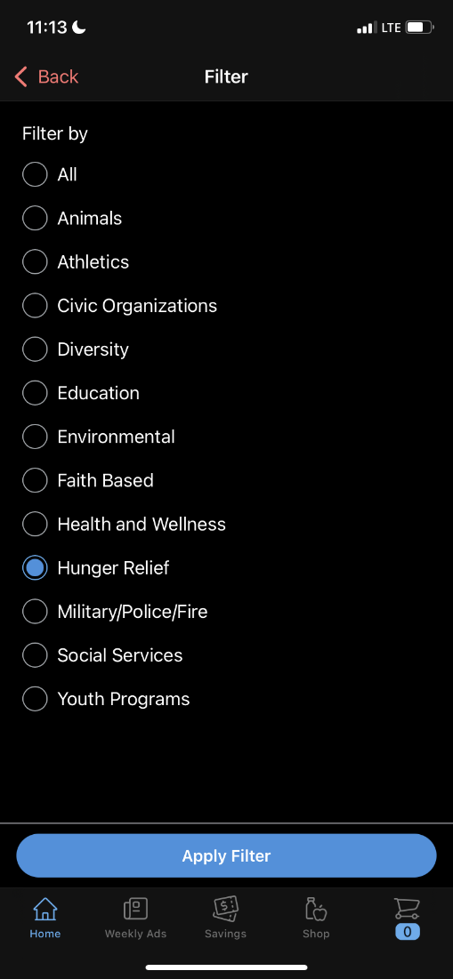

Type or scroll to find an organization, then click enroll

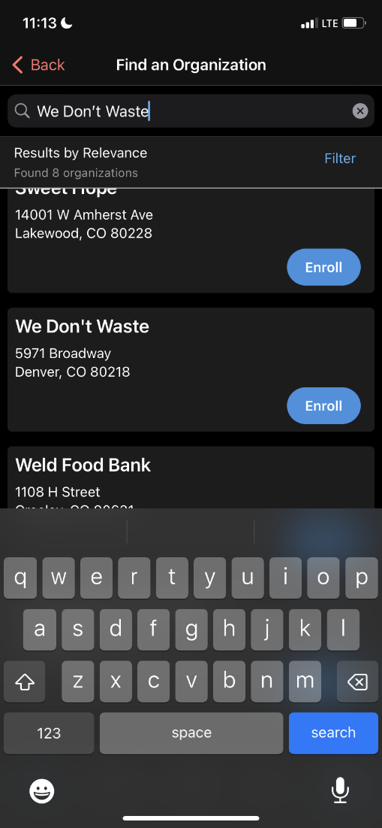

It’s that simple, you are now enrolled in Community Rewards!

